Spermatic cord and ductus deferens

Definition
Spermatic cord is a matrix of connective tissue continuous proximally with the preperitoneal connective tissue

Extension
From the upper pole of the testis to deep inguinal ring

Coverings of the spermatic cord
Three fasciae
- External spermatic fascia (from external oblique fascia)
- Cremasteric fascia (from internal oblique fascia)
- Internal spermatic fascia (from fascia transversalis)

Components of spermatic cord

​​​​​​​Ductus deferens
- Three arteries
- Testicular artery
- Cremasteric artery
- Artery to vas deferens
- Three veins
- Pampiniform plexus and testicular vein
- Cremasteric vein
- Veins from vas deferens
- Three nerves
- Genital branch of genitofemoral nerve
- Ilioinguinal nerve
- Sympathetic nerves (testicular plexus)
- Lymphatics

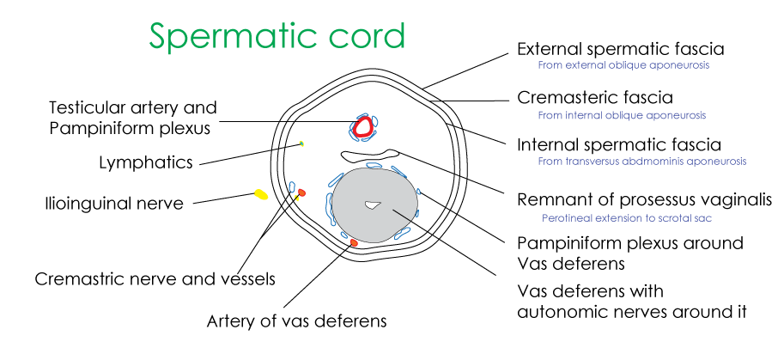

Ductus deferens
Thick-walled muscular tube extending from tail of epididymis up to joining of duct of seminal vesicle
Length - 45 cms

Structures that are 45 cm (18 inches)
- Ductus deferens
- Umbilical cord
- Spinal cord
- Thoracic duct
- Transverse colon
- Sartorius muscle
- Distance between the incisor tooth to the cardiac end of the stomach

Course
Passes through four regions
- Scrotum
begins as continuation of the epididymis
- Spermatic cord (within the inguinal canal)
From the upper pole of testis to deep inguinal ring via superficial inguinal ring and inguinal canal
- Abdominal
Begins at the deep inguinal ring
Turns around the inferior epigastric artery
Crosses the external iliac vessels
Later located within the lateral wall of pelvis
- Pelvic cavity
In the pelvis - it crosses superior vesical vessels, obturator nerve, obturator vessels, inferior vesical vessels and ureter
Turns towards the base of urinary bladder
Joins the duct of seminal vesicle and forms ejaculatory duct

Amupulla
Terminal dilated part of ductus deferens

Ductus deferens

At risk relations in the pelvis
- Lateral to the umbilical artery
- Lateral to the obturator nerve and vessels
- Lateral to the superior vesical vessels
- Anteromedial side of the ureter
- Posterior aspect of the bladder
- Medial to the seminal vesicles where it becomes dilated as the ampulla

Blood supply
Ductus deferens is supplied by artery of ductus deferens (branch of inferior vesicular artery)
Deferential vein drains into the pelvic plexus

Applied aspects - Torsion of testis
Twisting of spermatic cord
Leading to cutting off the blood supply to testis
Patient suffers from excruciating pain
Cremasteric reflex is absent
Prolonged ischemia may interfere with sperm production
It’s a surgical emergency
Immediate surgical intervention to restore the blood supply can salvage the testis

Applied aspects – Vasectomy
Surgical procedure of where the ductus deferens is cut and ligated for permanent sterilization of the males
Anatomical basis
Ductus deferns tube is cut and ligated - Lead to blockage of the tube carrying semen
During the procedure, ductus is cut high in the scrotum, routinely a part of the ductus is also cut to prevent spontaneous recalization

No-Scalpel Vasectomy (NSV)
A special hemostat is used to make the scrotal skin puncture.
Ductus deferens is identified and ligated

